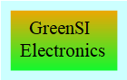
GreenSI IGBT 90kW GSI_VX_0544-a THT
Gen:X3

manufactured by: GreenSI Electronics
configuration: | Individually
Collector-emitter blocking voltage U(CES): | 600V
collector current I(C): | 300A
I(CM): | 400A
VCE saturation (max): | 5 v
Power (max) P(TOT): | 90kW
input type: | default
package: | TO-247AD
Switch-on delay time t(d)(on): | 19 ns
Switch-off delay time t(d)(off)(2): | 60ns
collector residual current I(CES): | 300µA
input capacitance: | 1960pF
series: | GenX3
mounting type: | THT
Product Type: | IGBT
Operating temperature max.: | 180°C
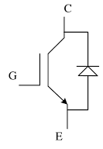  Operating temperature min.: | -50°C
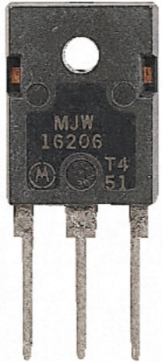  Heating/W Powerloss: | 0.25°C
